

BIT 4107 – Mobile Application Development
ENHANCED PROFESSIONAL STUDENT LOGBOOK
Student Name: SHEILA WAITHERA MURIITHI
Admission Number: BIT/2024/32455
Academic Year: YEAR 4
Semester: SEM II
Lecturer: Mr. Nyoro

Table of Contents
Landing page 3
Create account page 4
Login page 5
Customers dashboard 6
Customers Cart 6
Customers Checkout page 7
Admin Dashboard 8
Tools used; 10
Personal reflection: 11

Landing page
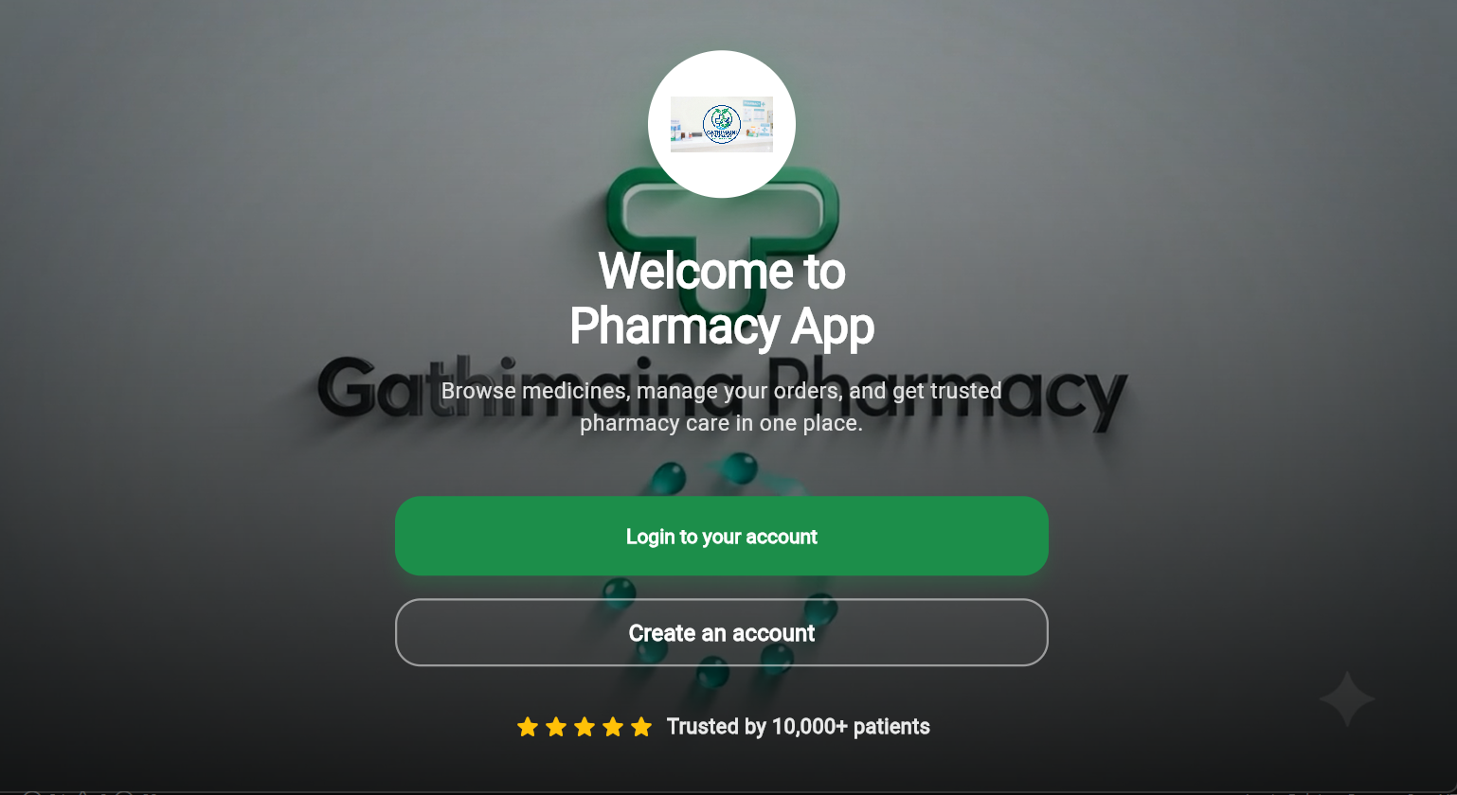

Create account page 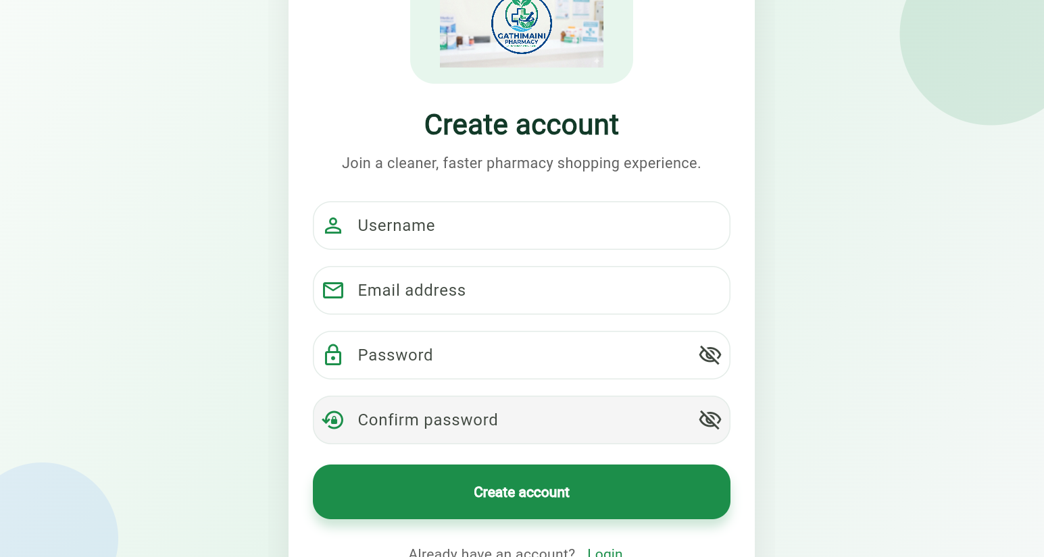

Login page
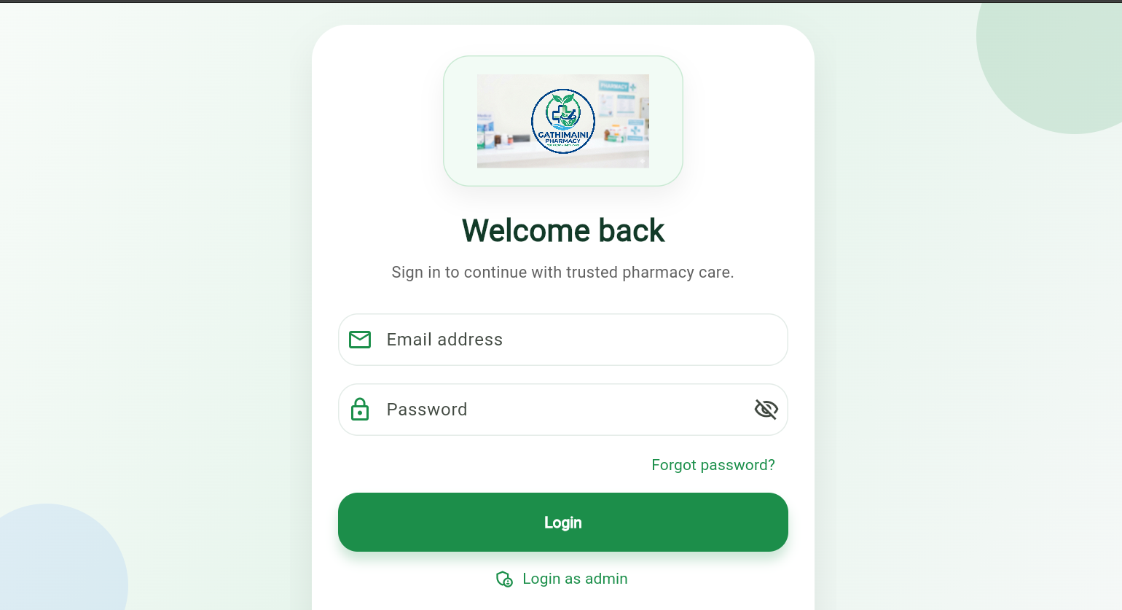

Customers dashboard
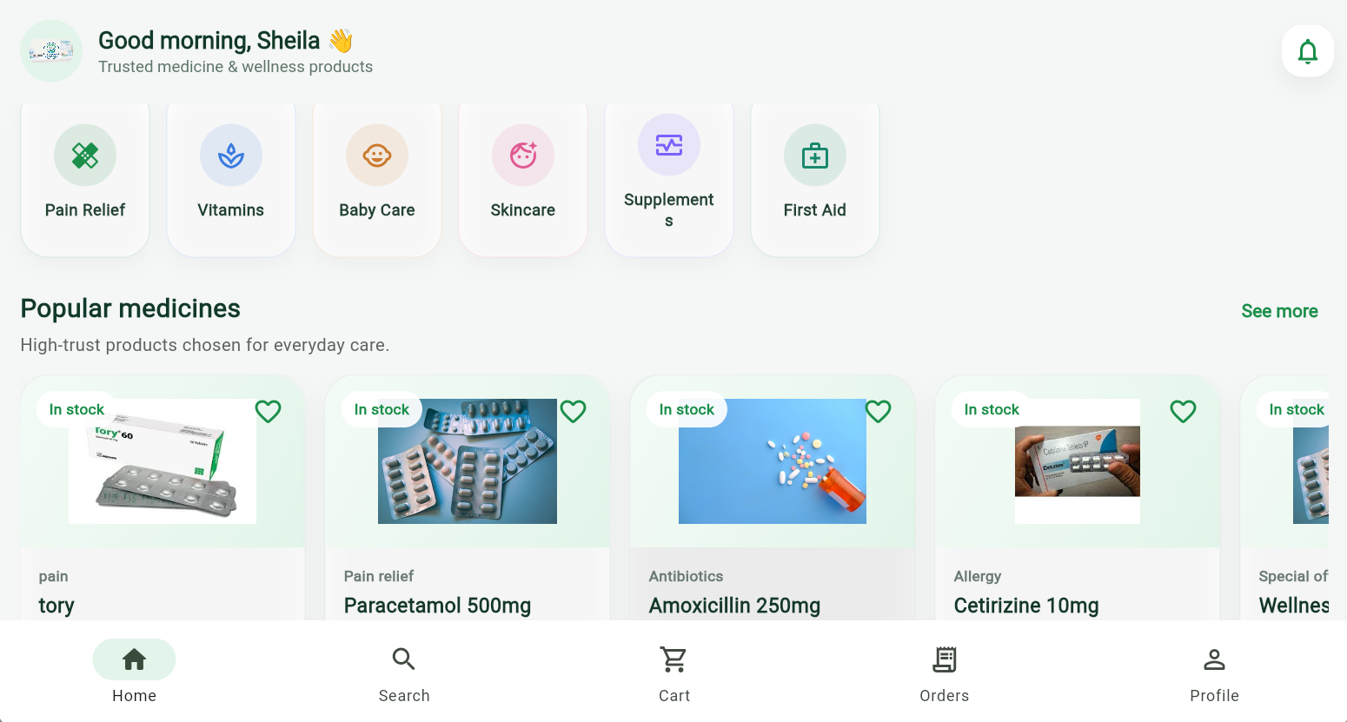

Customers Cart
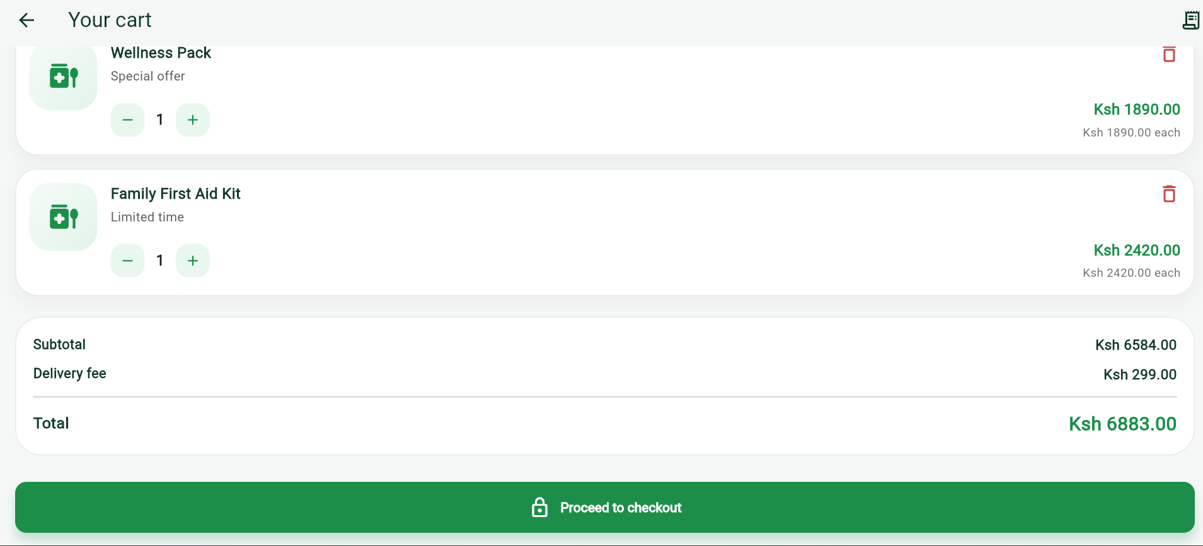

Customers Checkout page
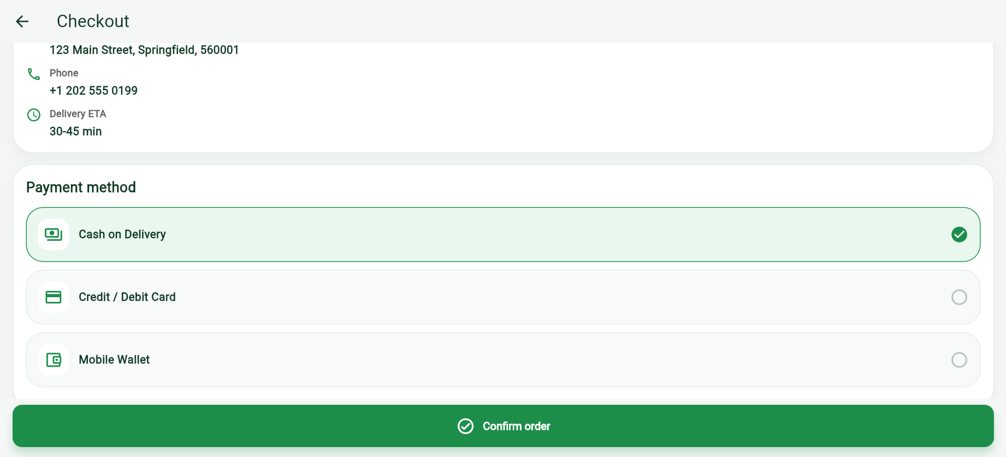

Admin Dashboard
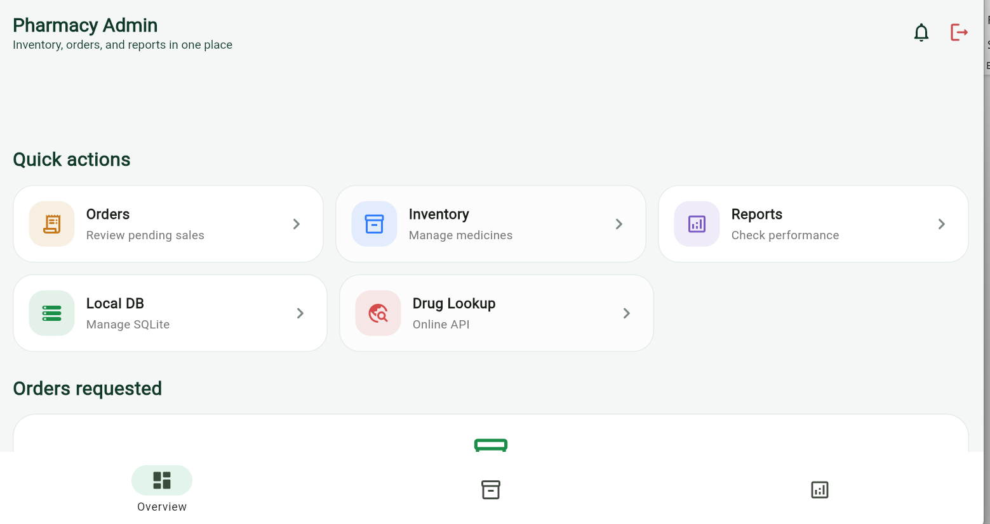

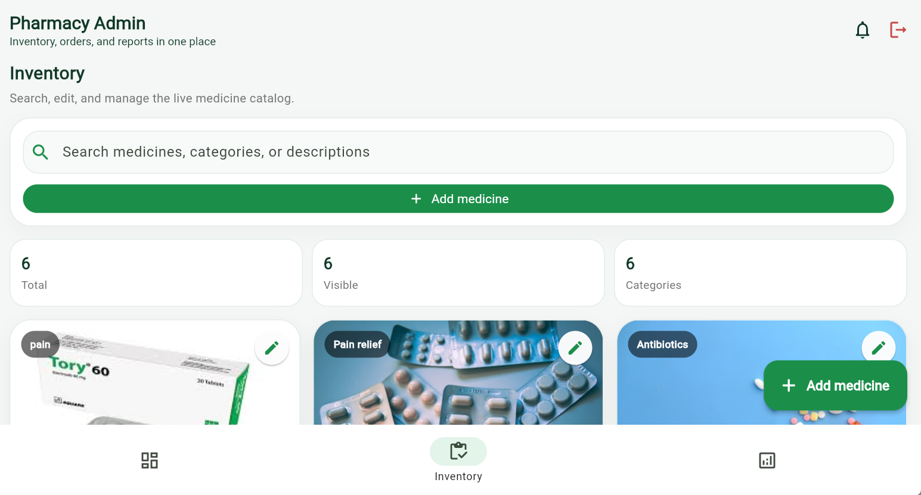

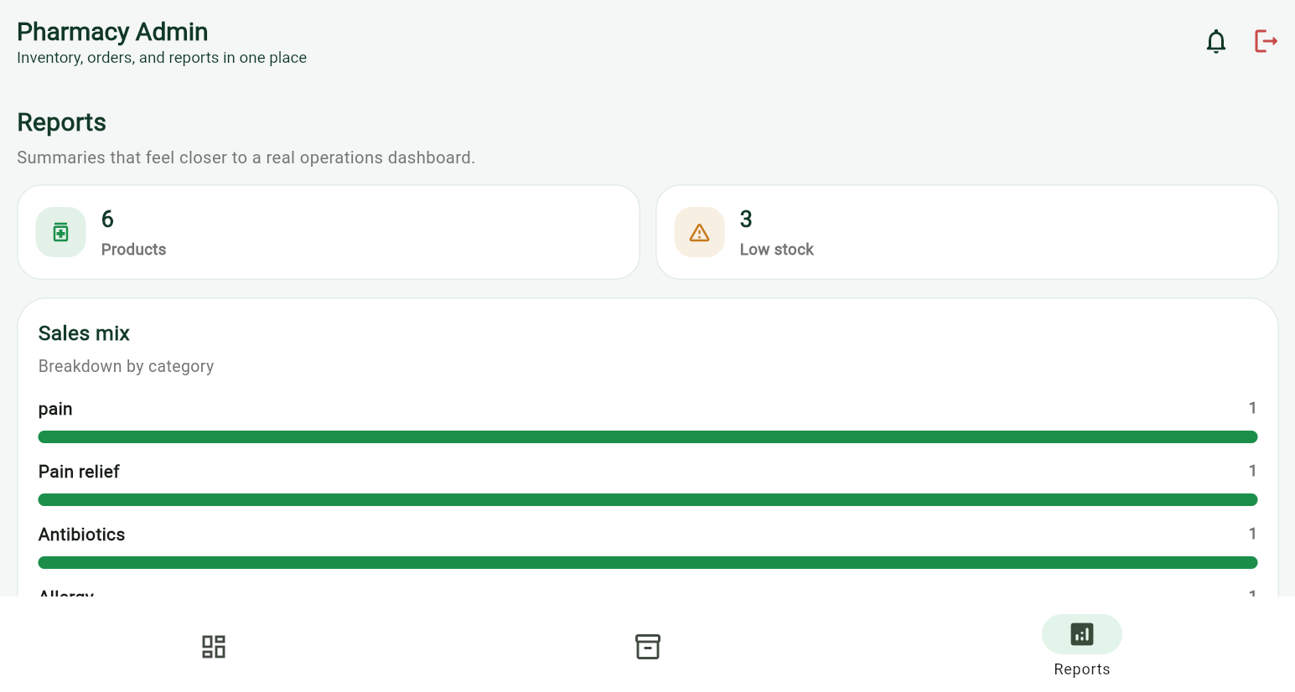

Tools used;
Flutter: The UI toolkit used to build the entire cross-platform application.
Dart: The underlying programming language.
Data Storage & Persistence
- SQLite (sqflite): Serves as the primary local database. It is implemented in the Database Helper class to handle robust offline CRUD operations for the pharmacy's medicine inventory.
- sqflite_common_ffi_web: A specialized package initialized in main. Dart that allows the SQLite database to function correctly when the app is compiled and run on the Web.
- Shared Preferences (shared preferences): Used for lightweight, key-value data persistence. It powers the AUTH Service to keep users logged in, saves the shopping cart state, caches order and prescription history in Pharmacy Service, and stores user profile details in Profile Screen.
Networking & APIs
- http Package: Used in drug_lookup_screen. dart to handle asynchronous network requests.
- open FDA API: A public REST API (https://api.fda.gov) consumed by the app. It allows administrators to search a live database of "HUMAN PRESCRIPTION DRUGS" and seamlessly import new items into their local SQLite inventory.
State Management & Architecture
- Provider (provider): Used at the application root (main. Dart) via ChangeNotifierProvider to supply global states like the Medicine Provider.
- Streams & Stream Controller: Heavily utilized within Pharmacy Service. By broadcasting streams (e.g., medicines Stream, orders Stream), the app ensures that UI components like the Home Screen and Profile Screen reactively update whenever the underlying data changes.
- Singleton Pattern: The core logic is structured using singletons (e.g., PharmacyService.instance, AuthService.instance, DatabaseHelper.instance) to maintain a single, synchronized source of truth throughout the app lifecycle.
UI & Media Handling
- Material Design 3: The app utilizes Flutter's latest Material 3 design language, configured via a robust Theme Data setup in main. Dart.
- Media Packages: As outlined in the README.md, the system relies on packages like image picker, file_picker, and video_player to facilitate the upload of prescription photos and documents, as well as to play landing screen media.
JSON Serialization (dart: convert): Used extensively to convert dart objects to JSON strings (and vice-versa) for saving complex lists like Cart items and Orders into Shared Preferences, as well as parsing the REST API responses from the FDA.

Personal reflection:
Developing this pharmacy application highlighted the power of offline-first architecture. Integrating local SQLite storage with live open FDA REST APIs, while utilizing Streams for reactive state management, demonstrated how bridging robust local data handling with external services creates a seamless, reliable cross-platform user experience.

